Lab # 04



Fall 2024

**CSE-411L Intro to Game Development Lab**

Submitted by: MUHAMMAD SADEEQ

Registration No.: 21PWCSE2028

Section: C

“On my honor, as a student of the University of Engineering and Technology, I have neither given nor received unauthorized assistance on this academic work”

Submitted to:

Engr. Abdullah Hamid

(27 Oct 2024)

Department of Computer systems engineering

University of Engineering and Technology, Peshawar

1. Created a Unity scene with name Lab 4
2. Created 3 cubes
3. Color each cube differently

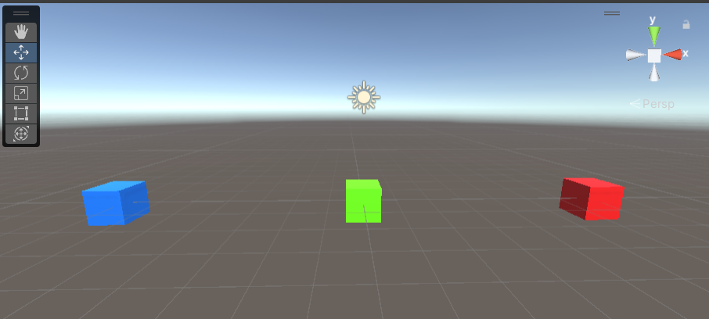

1. I Applied 3 different scripts on each cube with the following logic
2. First cube display “Hello” on console and constantly rotate in vector3.up direction

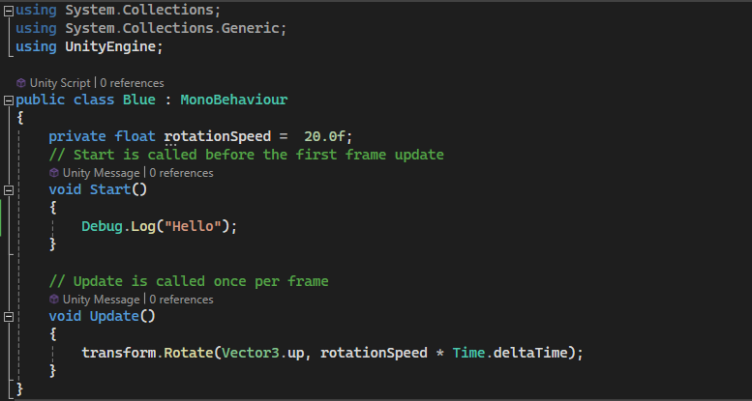

1. Second cube display “World” on console and start to move in vector3.up direction and after covering some distance it stop and comeback to its original position

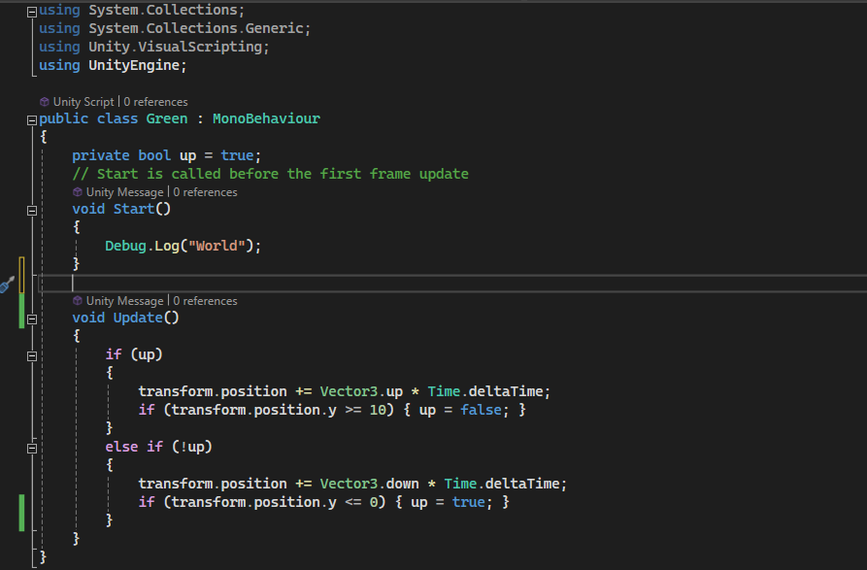

1. Third cube increase its scale to 10 and then back to 1 and constantly keep on increasing and decreasing scale.

